DATA ENCODING TECHNIQUES
An Assignment on Digital and Analog Data Encoding Methods

Course: Data Communication and Computer Networks
Topic: Encoding, Decoding, and Digital-to-Digital Encoding Schemes
Date: September 2026

Table of Contents

1. Introduction to Encoding and Decoding
Encoding, put simply, is how we take data — a sequence of characters, symbols or alphabets — and convert it into a format that can travel securely and reliably across a communication channel. Think about what actually happens inside a data communication system: whatever the source produces, whether that's human speech, a video signal, or digital data straight out of a computer, has to be turned into electrical, optical, or electromagnetic energy before it can move across a transmission medium like a copper wire, an optical fibre, or even just open air. That conversion step is what we're calling encoding.
Decoding is basically the mirror image of encoding. Once the signal reaches the receiving end, it has to be interpreted and converted back into the original information before the destination device or application can actually make use of it. If the receiver doesn't have a matching decoding scheme, the signal it receives is just noise — it means nothing. That's why encoding and decoding always come as a pair, and it's also why the transmitter and receiver have to agree beforehand on exactly which scheme they're using.
It helps to understand why encoding is needed in the first place by thinking of the communication path as having two separate layers of representation. At the logical layer, information is just abstract symbols — letters, numbers, or the binary digits 0 and 1 that a computer works with internally. At the physical layer, though, the only things that can actually travel through a real medium are continuously varying physical quantities: voltage on a wire, light intensity in a fibre, or the amplitude and phase of a radio wave. Encoding is what bridges these two layers — it lays down a precise, agreed rule for mapping every possible symbol or bit pattern onto a specific physical signal state, and decoding is simply the rule for undoing that mapping. This is treated as one of the foundational problems of the physical layer in standard textbooks like Behrouz A. Forouzan's 'Data Communications and Networking' and Andrew S. Tanenbaum's 'Computer Networks', and for good reason: every other layer of a network — data link, network, transport, application — ultimately depends on bits being delivered correctly across this physical boundary.
When engineers design an encoding scheme, they usually have several goals in mind, and these goals often pull in different directions:
- Bandwidth efficiency — ideally the encoded signal takes up as little frequency spectrum as possible for a given data rate, since spectrum and cable bandwidth aren't free or unlimited.
- Noise and interference immunity — the signal needs to stay distinguishable at the receiver even after the transmission medium and electrical noise have weakened and distorted it along the way.
- Self-synchronisation, or clock recovery — the receiver has to know exactly where one bit interval ends and the next starts, and ideally it should be able to pull that timing information straight from the signal itself rather than needing a separate clock line.
- Simplicity of implementation — the encoder and decoder, whether that's circuitry or, in modern systems, signal-processing algorithms, shouldn't be needlessly complicated or expensive to build.
- Error detection capability — some schemes are deliberately built so that certain transmission errors produce a signal pattern that breaks the coding rules, which lets the receiver notice that something went wrong.
No single scheme manages to hit all of these goals at once, which is really the whole reason a whole family of different techniques has grown up over time, each one striking its own balance. In this assignment I'll first survey the major categories of data encoding, and then spend most of the time on digital-to-digital schemes specifically — Non-Return-to-Zero (NRZ), Bi-phase (Manchester) encoding, and block coding techniques like 4B/5B and 8B/6T.

2. Data Encoding
In the context of digital transmission specifically, encoding just means using patterns of voltage or current to represent the binary 1s and 0s travelling along a link. The particular pattern chosen for the bits is called a line code, and applying that pattern is called line encoding.

2.1 Common Types of Line Encoding
The line encoding formats you'll come across most often fall into four broad families, and what really separates them is how many distinct voltage levels each uses and how the DC, or average, component of the resulting signal behaves:
- Unipolar — only a single non-zero voltage level (usually positive) is used for one of the two bit values, and the other bit value just sits at zero voltage. It's about as simple as a scheme gets, but it produces a large DC component, since the average signal value drifts away from zero whenever there are more 1s than 0s, or the other way round.
- Polar — here we use two voltage levels, one positive and one negative, which keeps the average signal level much closer to zero than a unipolar scheme would. NRZ-L and NRZ-I, which I go into in detail in Section 4, both fall into this polar category.
- Bipolar, or Alternate Mark Inversion (AMI) — three voltage levels come into play here: zero volts represents one bit value (usually 0), while the other bit value (usually 1) alternates between positive and negative pulses. Because consecutive 1-bits keep flipping polarity, the long-term average of the signal stays very close to zero, which is why this family is sometimes also called 'pseudo-ternary'. There's a nice side benefit too — if a single-bit error flips the polarity of one pulse, it breaks the strict alternation pattern, so the receiver can actually use bipolar encoding as a built-in, if basic, error-detection mechanism.
- Manchester (Bi-phase) — a transition in the middle of every bit interval encodes the bit value, combining clocking and data in a single signal.

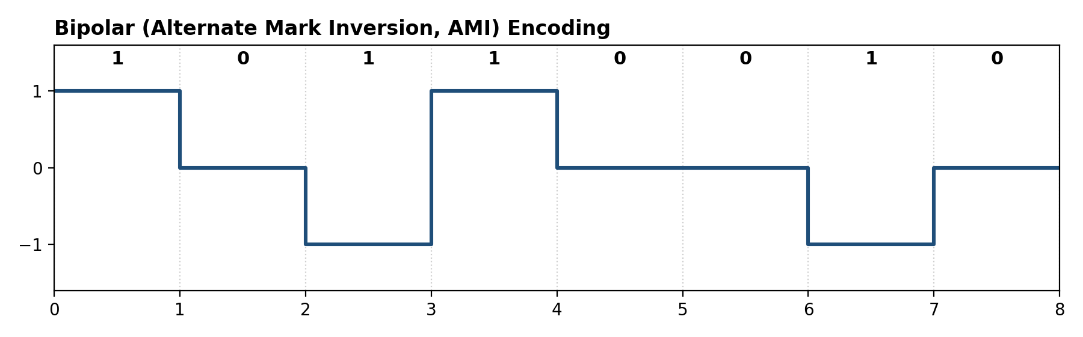
Figure A: Bipolar (Alternate Mark Inversion) encoding of the byte 1 0 1 1 0 0 1 0 — note how successive 1-bits alternate polarity while 0-bits stay at zero volts (author-generated illustration).
Scheme | Voltage Levels | Key Characteristic | Typical Drawback
Unipolar | 1 (On/Off) | Simple; uses one polarity only | DC component; poor synchronisation
Polar | 2 (+V / -V) | Reduced DC bias compared to unipolar | Still loses sync on long bit runs
Bipolar (AMI) | 3 (+V / 0 / -V) | Zero has no DC component; alternating pulses give error detection | Long runs of 0s still cause sync loss
Manchester | 2, with mid-bit transition | Self-clocking; no DC component | Requires twice the bandwidth of NRZ

3. Encoding Techniques — Classification
Broadly speaking, data encoding techniques fall into four categories, and which category you land in depends on two things: whether the source data is analog or digital, and whether the signal carrying it is analog or digital.

3.1 Analog Data to Analog Signals
When the source data is analog — human voice or a video signal, say — and it needs to ride on an analog signal such as a radio-frequency carrier wave, we turn to modulation. The way modulation works is that we take a high-frequency sinusoidal 'carrier' signal, chosen mainly because it propagates well and can be slotted into a specific radio channel or frequency band, and vary one of its three basic parameters — amplitude, frequency, or phase — in proportion to the low-frequency message signal that's actually carrying the information. This step is necessary because most 'baseband' analog signals, raw voice being the obvious example, sit in a frequency range that's either impractical to send directly over the air or would collide with other baseband signals sharing the same medium. There are three classical modulation techniques in this category:
- Amplitude Modulation (AM) — the carrier's amplitude, essentially its peak height, is varied in proportion to the instantaneous amplitude of the message signal, while its frequency and phase stay fixed. AM is easy to implement and demodulate, which is exactly why it became the basis of the earliest commercial radio broadcasting, but it's fairly susceptible to noise, since electrical noise tends to show up as unwanted amplitude fluctuations.
- Frequency Modulation (FM) — this time it's the carrier's frequency that varies in proportion to the message signal's amplitude, while the carrier's own amplitude stays constant. Since the information now lives in frequency variations rather than amplitude ones, FM receivers can mostly ignore amplitude-based noise, which is exactly why FM broadcasting sounds noticeably clearer than AM.
- Phase Modulation (PM) — here the carrier's phase angle varies in proportion to the message signal's amplitude, with the amplitude and instantaneous frequency otherwise held steady. PM is mathematically very close to FM, close enough that the two are often lumped together under the term 'angle modulation'.
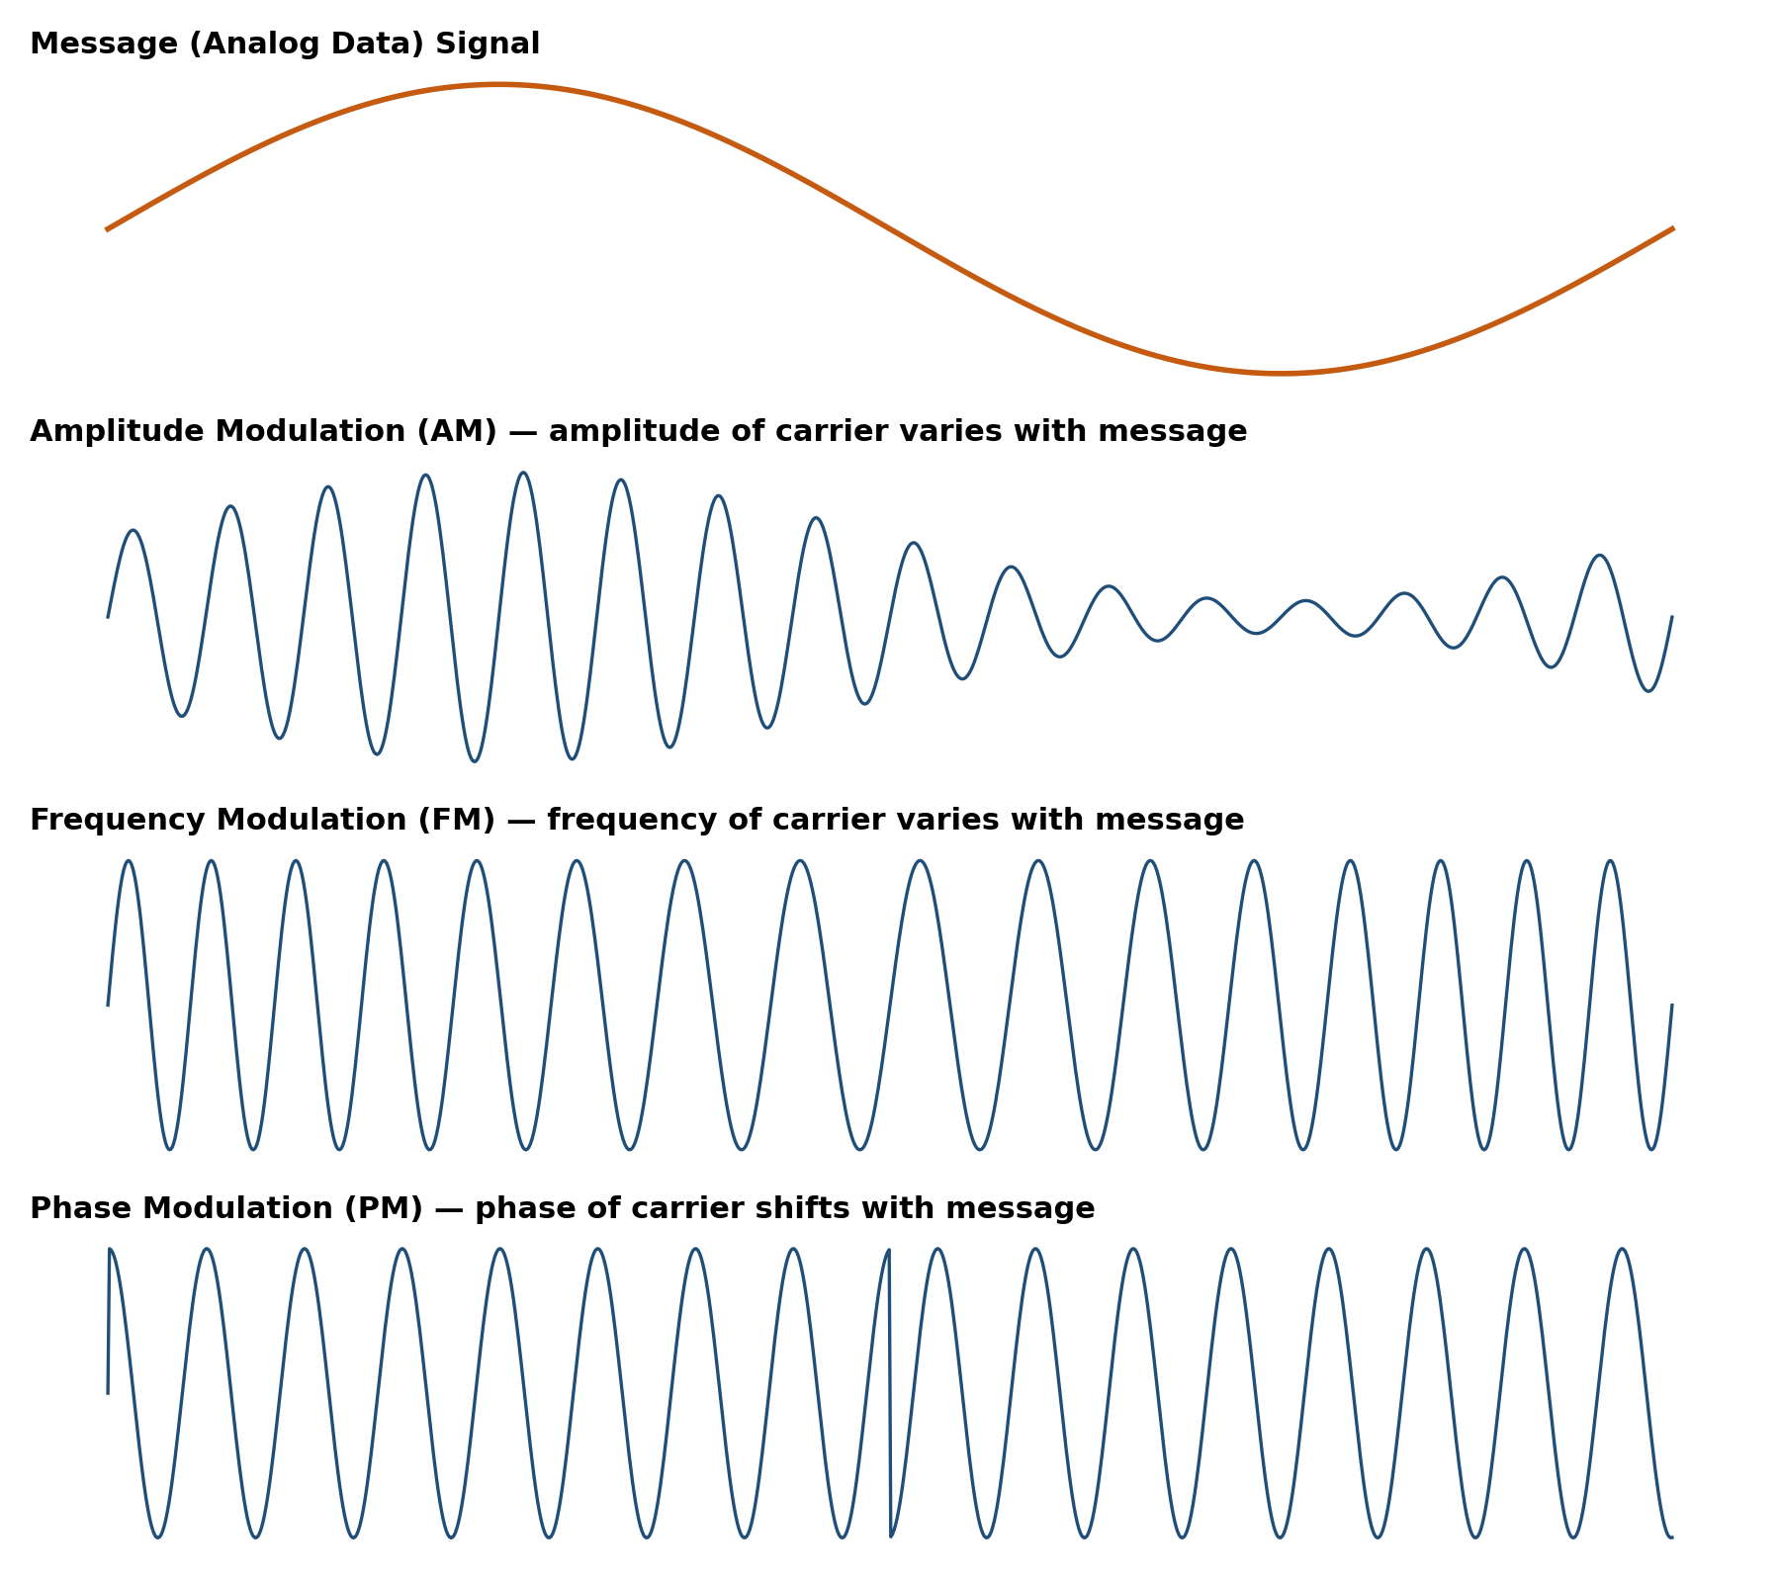
Figure B: Conceptual comparison of AM, FM and PM applied to the same message signal (author-generated illustration).

3.2 Analog Data to Digital Signals
Turning analog data into a digital signal is called digitisation, and the main tool for doing this is Pulse Code Modulation, or PCM. PCM works through three steps, done one after another:
- Sampling — the continuous analog signal gets measured at regular intervals. According to the Nyquist sampling theorem, the sampling rate needs to be at least double the highest frequency present in the signal, otherwise you run into aliasing.
- Quantisation — each sample's amplitude gets rounded off to the closest value in a fixed, finite set of discrete levels.
- Encoding — finally, each quantised level is assigned a binary code word, and that's what actually gets sent out as a digital bit stream.
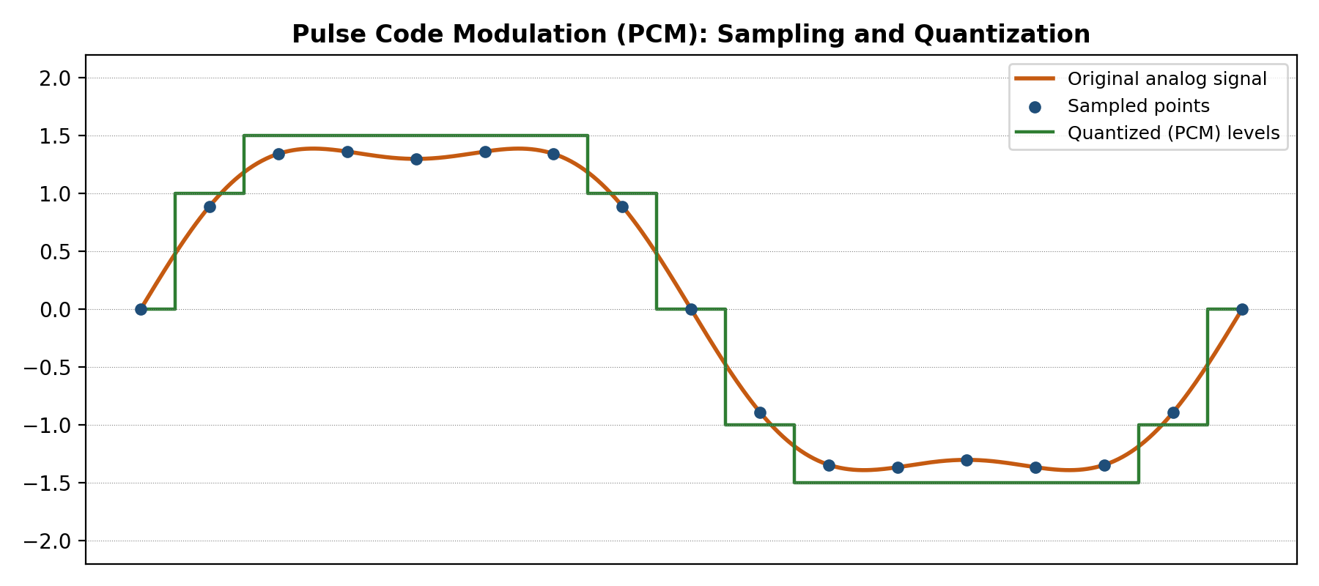
Figure C: Sampling and quantisation of an analog waveform, the first two steps of PCM (author-generated illustration).
The small gap between the true analog sample value and its nearest permitted quantisation level — you can see this in Figure C as the small vertical distance between the orange curve and the green step function — is what we call quantisation error, or quantisation noise. You can shrink this error by adding more quantisation levels, which just means using more bits per code word, but that comes at the cost of a higher bit rate. Standard telephone-quality PCM, for instance, uses 8 bits per sample at 8,000 samples per second, which works out to a bit rate of 64 kbps per voice channel.
There's also Delta Modulation (DM), which takes a different approach — instead of encoding the absolute sample value, it only encodes the change, or 'delta', between one sample and the next. At each sampling instant the encoder just sends a single bit saying whether the signal went up or down relative to the previous sample, by one fixed step size. Because it only needs one bit per sample rather than a whole code word, DM is considerably simpler to build than PCM and needs less circuitry. The catch is that it can suffer from slope-overload distortion when the input changes faster than the fixed step size can keep up with, and from granular noise — a persistent low-level 'hunting' oscillation — when the input barely changes at all. Pick the step size well for a given signal, though, and delta modulation can actually give a better output-to-bit-rate trade-off than a coarsely quantised PCM system, which is why adaptive versions of it are still used in some low-bit-rate voice-coding applications today.

3.3 Digital Data to Analog Signals
Sometimes digital data has to travel over a medium built for analog signals — the public telephone network is the obvious example — and in that case we use digital modulation, often just called 'keying'. The three basic keying techniques are:
- Amplitude Shift Keying (ASK) — the carrier's amplitude switches between discrete levels to represent the bits; a common version simply sends a burst of carrier for a 1 and nothing at all for a 0.
- Frequency Shift Keying (FSK) — here it's the carrier's frequency that switches between discrete values to represent the binary data.
- Phase Shift Keying (PSK) — the carrier's phase gets shifted by a set amount to represent the data. Binary PSK (BPSK) just needs two phases, 180 degrees apart, while Quadrature PSK (QPSK) uses four distinct phases and can pack two bits into every transmitted symbol, effectively doubling the data rate for the same signalling rate.
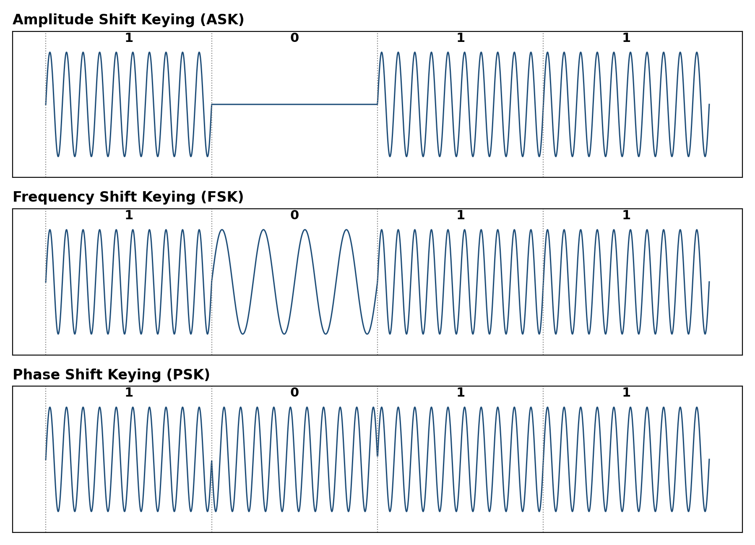
Figure D: ASK, FSK and PSK waveforms for the same 4-bit sequence 1 0 1 1 (author-generated illustration).
As Figure D shows, ASK is the easiest of the three to generate and detect, but it's also the most vulnerable to amplitude-based noise and signal fading, since noise can produce a 'no-signal' burst that's easily mistaken for a transmitted 0. FSK sidesteps this by keeping the carrier present at all times and only switching its frequency, which makes it noticeably more robust — that's actually why FSK became a popular choice for early, low-speed modems. PSK generally gives the best noise performance of the three for a given transmitted power, and its multi-phase variants, QPSK and higher-order PSK, form the basis of most modern high-speed digital modems and wireless standards. In real modems, phase and amplitude keying are usually combined together in schemes called Quadrature Amplitude Modulation (QAM), which packs more bits into every symbol while keeping bandwidth demands manageable.

3.4 Digital Data to Digital Signals
This last category is really the most important one for computer networks, since it's what determines how the 1s and 0s coming out of a network interface get represented as voltage or current levels straight onto a cable, with no analog carrier involved at all. There isn't just one way to map digital data onto a digital signal — several schemes exist — and the rest of this assignment digs into the most significant ones: Non-Return-to-Zero (NRZ) and its variants, Bi-phase encoding, and block coding.

4. Non-Return-to-Zero (NRZ) Encoding
NRZ codes represent binary 1 with a High voltage level and binary 0 with a Low one. What really defines NRZ, though, is that the voltage stays constant across the whole bit interval — it never drops back down to a zero or reference level between bits. So if two consecutive bits happen to be the same value, the signal just holds steady at that voltage; nothing changes at the boundary between them.
In terms of bandwidth this is actually pretty efficient, since a transition only has to happen when the bit value changes. But it does create a real problem in practice: whenever a long run of identical bits shows up, the voltage just sits flat for a stretch. And because there's no transition marking where one bit interval ends and the next begins, the receiver's clock — which depends on those transitions to stay synced with the transmitter — can slowly drift out of alignment. This is what people mean by loss of clock synchronisation, and it makes it genuinely hard for the receiver to count exactly how many identical bits went by.
It's worth pointing out that NRZ isn't just a historical footnote — in one form or another it's still the baseline everything else in this assignment gets measured against, simply because it's the most bandwidth-efficient way possible to map one bit onto one signal element. Every other scheme covered below — Manchester, Differential Manchester, 4B/5B, 8B/6T — exists specifically to patch NRZ's synchronisation weakness, usually by giving up some of that bandwidth efficiency in exchange for more reliable clocking. There are two important variants of NRZ worth knowing: NRZ-L and NRZ-I.

4.1 NRZ-L (NRZ Level)
With NRZ-L, the signal's polarity only flips when the incoming bit value actually changes — going from 1 to 0 or 0 to 1. Each bit value maps directly onto a specific voltage level (say, 1 for positive and 0 for negative), so at any given moment the voltage level literally is the bit value. This is really just basic NRZ behaviour, and by convention the very first bit of a transmission usually gets an initial polarity change to set the starting reference level.
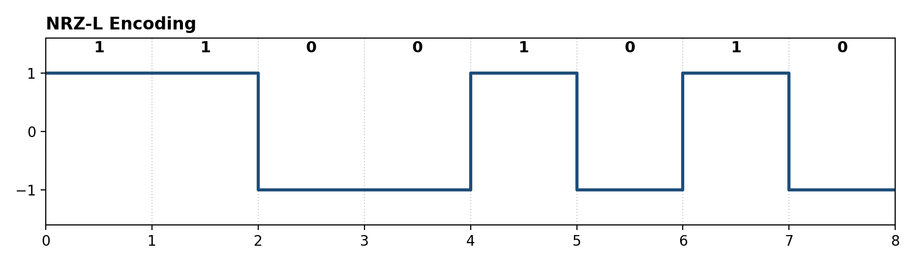
Figure 1: NRZ-L waveform for the bit sequence 1 1 0 0 1 0 1 0 (author-generated illustration).

4.2 NRZ-I (NRZ Inverted)
NRZ-I does things a bit differently — instead of tying the bit value to a voltage level, it ties the bit value to a transition. When the incoming bit is a 1, the level flips (a transition happens) right at the start of that bit interval. When the bit is a 0, nothing happens and the signal just carries on at whatever level it was already at. Because of this, NRZ-I counts as a differential encoding scheme: to decode a bit you have to compare the current level against the previous one, you can't just read the level on its own.
One practical advantage NRZ-I has over NRZ-L is that it doesn't care if the two wires in a twisted-pair cable get accidentally swapped, since the information lives in whether or not a transition happens, not in some absolute polarity. If the two wires of an NRZ-L link get swapped, every single bit ends up inverted, and the data becomes unrecoverable unless you know the swap happened; an NRZ-I link, on the other hand, keeps decoding correctly even with the wires swapped, because 'a transition occurred' and 'a transition did not occur' stay true no matter which wire is treated as positive. This robustness is a big part of why NRZ-I, and not NRZ-L, ended up as the underlying line code for USB and for the 100BASE-TX / FDDI 4B/5B system covered in Section 6.
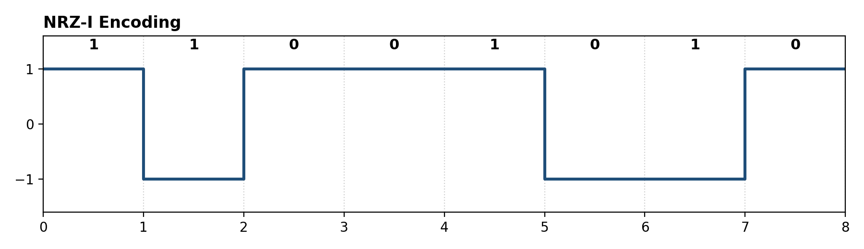
Figure 2: NRZ-I waveform for the same bit sequence 1 1 0 0 1 0 1 0 (author-generated illustration).

4.3 Limitations of NRZ Codes
Both NRZ-L and NRZ-I ultimately suffer from the same weakness mentioned above: a long run of identical bits (all 1s for NRZ-L, all 0s for NRZ-I) completely throws off synchronisation between the transmitter's clock and the receiver's clock. In practice, systems get around this either by running a separate dedicated clock line alongside the data, or by using bit-stuffing or scrambling to break up long runs of identical bits before they're even sent.

5. Bi-phase Encoding
Bi-phase encoding fixes the clock-synchronisation issue that plagues NRZ by guaranteeing at least one transition inside every single bit interval, no matter what pattern of bits is being sent. The signal level actually gets checked twice per bit: once at the start of the interval, once in the middle. Because these guaranteed transitions let the receiver derive its clock directly from the signal, Bi-phase codes are called self-clocking — the clock is essentially baked into the signal itself, so there's no need for a separate clock line.
Of course, this reliability isn't free — the cost is bandwidth. Since a transition has to happen at least once, and sometimes twice, in every bit interval, the modulation rate (how many signal changes occur per second) ends up double that of an equivalent NRZ signal running at the same bit rate. In other words, Bi-phase encoding needs roughly twice the bandwidth of NRZ to move data at the same speed.
There are two main flavours of Bi-phase encoding worth knowing: Bi-phase Manchester — usually just called 'Manchester encoding' — and Differential Manchester encoding.

5.1 Bi-phase Manchester Encoding
In Manchester encoding, there's always a transition at the middle of every bit interval, and the direction that transition goes in is what tells you the bit value:
- For a 1, the signal switches from High to Low right at the midpoint of the bit interval.
- For a 0, the signal switches from Low to High at that same midpoint.
Since the direction of that mid-bit transition is all you need to know the bit value, Manchester encoding is quite easy to decode, and it's also very resistant to DC bias problems — every bit interval contributes an equal amount of positive and negative signal, so things balance out. This is the scheme that was historically used in 10 Mbps Ethernet (IEEE 802.3) local area networks.
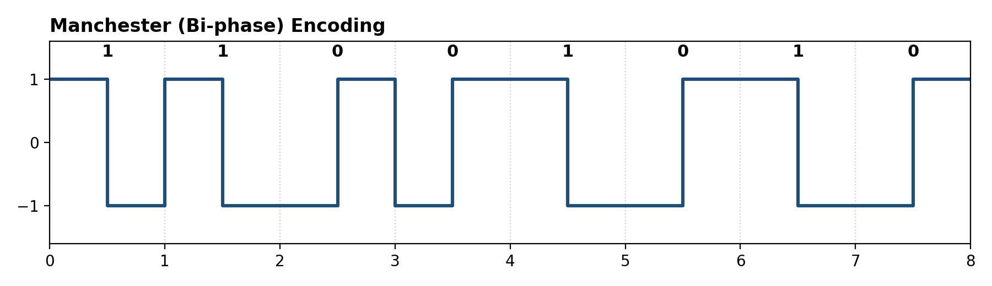
Figure 3: Manchester (Bi-phase) encoding for the bit sequence 1 1 0 0 1 0 1 0 (author-generated illustration).

5.2 Differential Manchester Encoding
Differential Manchester encoding also guarantees a mid-bit transition in every interval, but here that transition is purely for clock recovery — on its own it says nothing about the bit value. Instead, what actually tells you the bit value is whether there's an extra transition right at the start of the interval:
- If a transition occurs at the start of the bit interval, the bit being transmitted is 0.
- If no transition occurs at the start of the bit interval, the bit being transmitted is 1.
Since the bit value here depends on whether a transition happens rather than on an absolute signal level, Differential Manchester — much like NRZ-I — doesn't care if the two transmission wires get their polarity reversed. Historically, this scheme was used in Token Ring (IEEE 802.5) local area networks.
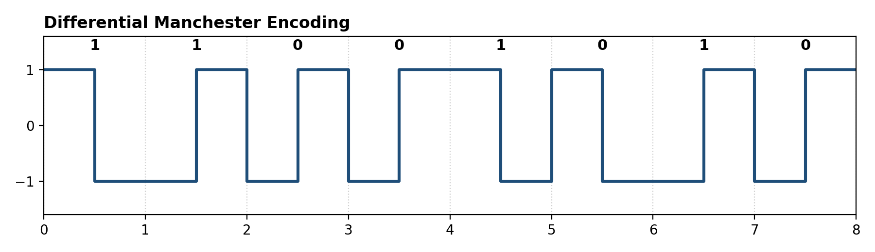
Figure 4: Differential Manchester encoding for the bit sequence 1 1 0 0 1 0 1 0 (author-generated illustration).

5.3 Comparison of Manchester and Differential Manchester
Aspect | Manchester | Differential Manchester
Mid-bit transition | Always present; direction encodes the bit | Always present; used only for clock recovery
Bit value indicated by | Direction of the mid-bit transition | Presence/absence of a transition at the start of the interval
Sensitive to wire reversal? | Yes | No
Historic use | 10 Mbps Ethernet (802.3) | Token Ring (802.5)

6. Block Coding
Block coding is a whole family of digital-to-digital encoding techniques where a fixed-size block of 'm' original data bits gets mapped onto a larger fixed-size block of 'n' coded bits, with n always greater than m. Those extra bits aren't wasted — they're what guarantee useful properties like a minimum number of transitions, a cap on how many identical bits can run together, and DC balance, all of which make the resulting signal much easier to synchronise and decode reliably. You'll usually see block coding schemes named with the notation mBnT, where 'm' is the number of input data bits, 'n' is the number of output symbols, 'B' stands for 'Binary', and 'T' stands for 'Ternary' (a three-level signal).
Of the many block coding schemes out there, two of the best known are 4B/5B and 8B/6T encoding.

6.1 4B/5B Encoding
As we saw, Manchester encoding needs a clock running at double speed compared to NRZ, purely because of those mandatory mid-bit transitions. 4B/5B was designed specifically to dodge that bandwidth penalty while still solving NRZ's clock-synchronisation headache. True to its name, every 4 bits of original data get mapped onto a 5-bit code group, and these groups are chosen so they always contain enough 1 bits — which in turn guarantees enough transitions once the 5-bit codes are sent out using NRZ-I.
The trick for getting around NRZ-I's clock-sync problem is to swap out every block of 4 consecutive data bits with a unique 5-bit code word pulled from a predetermined dictionary. When choosing these code words, the basic rule is that each one can start with at most one leading 0 and end with no more than two trailing 0s. Follow that rule and, however the 5-bit groups get strung together one after another, you're guaranteed at least two signal transitions per block — which is exactly what keeps the receiver's clock synchronised.
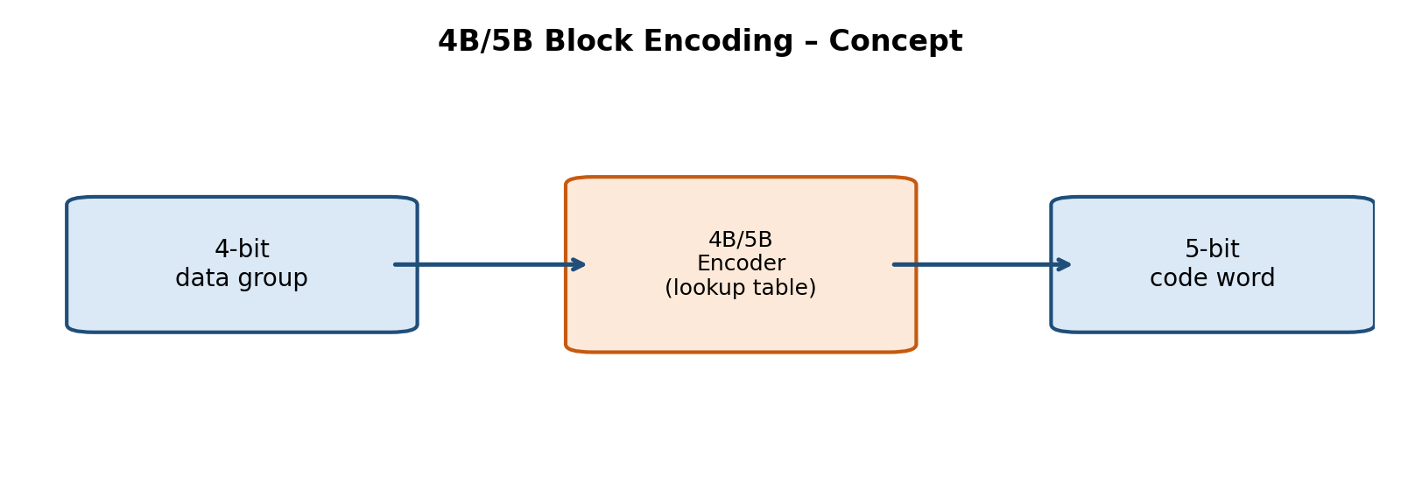
Figure 5: Conceptual block diagram of 4B/5B encoding (author-generated illustration).
There are 32 possible 5-bit code words in total, but only 16 are actually needed to cover the 16 possible 4-bit data values. That leaves plenty of spare code words, which get reserved for control purposes — signalling the start or end of a frame, or flagging an idle line, for instance. 4B/5B, paired with NRZ-I, is what's actually used in 100 Mbps Fast Ethernet (100BASE-TX) and in the FDDI standard.

6.2 8B/6T Encoding
Everything discussed so far has used just two voltage levels to represent a single bit on a single wire. But if you allow more than two voltage levels per signal, you can suddenly pack more than one bit into each signal element, which boosts the effective data rate for a given signalling, or baud, rate.
8B/6T is exactly this kind of multilevel scheme: it uses 6 signal elements, each one able to sit at one of 3 discrete voltage levels (that's where the 'Ternary' comes from), to represent every 8 bits of input data. Do the maths on 6 ternary positions and you get 3 to the power of 6, or 729, possible signal patterns. Since representing every possible 8-bit value only actually needs 2 to the power of 8, or 256, combinations, there's a huge surplus left over — 729 minus 256 is 473 spare patterns — and just like in 4B/5B, these extras get used to improve DC balance and provide additional control symbols.
You'll find 8B/6T in 100BASE-T4 Fast Ethernet, a standard designed specifically to push 100 Mbps Ethernet over the lower-grade Category 3 twisted-pair cabling that a lot of buildings already had installed for 10BASE-T Ethernet.

6.3 Worked Example: Encoding the Byte 10110010
To make all of this a bit more concrete, let's walk through how the 8-bit byte 1 0 1 1 0 0 1 0 would actually look under three of the digital-to-digital schemes covered in this assignment.
Scheme | Rule applied | Resulting behaviour
NRZ-L | Level directly follows the bit value (1 = High, 0 = Low) | High-High-Low-High-High-Low-Low-High-Low (levels change only where the bit value changes)
NRZ-I | Transition at the start of the interval for 1; no transition for 0 | A transition occurs at every position where a '1' appears in the byte; the level holds steady at every '0'
Manchester | Mid-bit High-to-Low transition for 1; Low-to-High for 0 | Every one of the 8 bit intervals contains exactly one mid-bit transition, whose direction reproduces the original byte
This little example shows exactly why NRZ-L and NRZ-I can 'go quiet' for a while — look at the two consecutive 0s and, separately, the two consecutive 1s in the byte: neither produces a transition in NRZ-L (since the bits repeat), and the 0s produce no transition in NRZ-I either. Manchester encoding, on the other hand, throws in a transition during every single bit interval regardless of what the data actually is.

7. Summary Comparison of Digital-to-Digital Encoding Schemes
The table below pulls together all the encoding schemes covered here and compares them on the things that actually matter for network design in practice: bandwidth efficiency, self-clocking ability, and where each one gets used in the real world.
Scheme | Self-Clocking? | Relative Bandwidth | Typical Application
NRZ-L | No | Low (baseline) | Short-distance digital logic links
NRZ-I | No | Low (baseline) | USB, some magnetic recording systems
Manchester | Yes | High (2x NRZ) | Classic 10 Mbps Ethernet (10BASE-T)
Differential Manchester | Yes | High (2x NRZ) | Token Ring networks
4B/5B (with NRZ-I) | Yes | Moderate (1.25x NRZ) | 100BASE-TX Fast Ethernet, FDDI
8B/6T | Partially (via code design) | Moderate | 100BASE-T4 Fast Ethernet

Looking at this comparison, two trends really stand out. First, there's a constant trade-off between reliable self-clocking and bandwidth efficiency — schemes that force a transition into every bit interval, like Manchester and Differential Manchester, are the easiest to keep synchronised but also the most bandwidth-hungry, while plain NRZ is efficient but fragile when it comes to sync. Second, block coding schemes like 4B/5B and 8B/6T land somewhere in between, almost by design — by adding a modest, carefully controlled amount of redundancy before transmitting with a simple NRZ-type line code, they get good synchronisation without paying the full double-bandwidth cost of Bi-phase encoding.

8. Practical Applications
- Local Area Networks — think Manchester encoding in classic Ethernet, Differential Manchester in Token Ring, and 4B/5B or 8B/6T in the various Fast Ethernet standards.
- Storage systems — variants of NRZ, along with run-length-limited codes, get used in magnetic and optical disk recording to squeeze in as much storage density as possible while still staying decodable.
- Telecommunication trunks — Bipolar (AMI) and later variants like B8ZS and HDB3 keep digital telephone trunk lines (T1/E1 circuits) timed correctly without needing a dedicated clock channel.
- Universal Serial Bus (USB) — combines NRZ-I encoding with bit stuffing so that periodic transitions are guaranteed for clock recovery.

8A. Glossary of Key Terms
Term | Definition
Bit interval | The fixed period of time allotted to transmit one bit of data.
Baud rate (modulation rate) | The number of signal elements (voltage changes) transmitted per second; may differ from the bit rate.
Self-clocking | A property of an encoding scheme whereby the receiver can recover timing information directly from the transmitted signal, without a separate clock line.
DC component | An unwanted constant (zero-frequency) offset in a transmitted signal, undesirable because many transmission media and transformers cannot carry DC.
Differential encoding | A scheme in which the bit value is represented by a change (or lack of change) relative to the previous signal state, rather than by an absolute level.
Bandwidth | The range of frequencies that a channel can carry, or that a signal occupies; higher modulation rates generally require greater bandwidth.
Redundancy (in block coding) | Extra bits added beyond the minimum required to represent the data, used to provide error detection, DC balance, or guaranteed transitions.
Bit stuffing | The practice of inserting extra, non-data bits into a stream to break up long runs of identical bits and preserve synchronisation.

8B. Self-Assessment Questions
Here are a few questions worth working through to check your understanding of the material covered above:
- Explain, in your own words, why NRZ-L and NRZ-I encodings are vulnerable to loss of clock synchronisation, and describe two practical ways this problem can be mitigated.
- Draw the NRZ-I and Differential Manchester waveforms for the bit sequence 1 0 0 1 1 1 0 1, and highlight the bit positions where each scheme produces a signal transition.
- Why does Manchester encoding require twice the bandwidth of NRZ encoding for the same data rate? Justify your answer in terms of the modulation rate.
- Explain the purpose of the 'extra' 5-bit code words in 4B/5B encoding that do not correspond to any 4-bit data value.
- Compare 4B/5B and 8B/6T encoding in terms of the ratio of transmitted signal elements to input data bits, and discuss the practical implication of this ratio for bandwidth efficiency.
- Give one real-world networking or storage standard that uses each of the following: Manchester encoding, Differential Manchester encoding, and 4B/5B encoding.

9. Conclusion
Data encoding is really one of the foundational ideas in data communications — it sits right at the boundary between the abstract world of bits and the physical world of voltages, light pulses, and radio waves. Over the course of this assignment, I traced the overall classification of encoding techniques — analog-to-analog modulation, analog-to-digital digitisation, digital-to-analog keying, and digital-to-digital line coding — and then went into digital-to-digital schemes in much more detail.
Within the digital-to-digital category itself, NRZ-L and NRZ-I are simple and bandwidth-efficient, but they fall apart when it comes to clock synchronisation over long runs of identical bits. Bi-phase schemes like Manchester and Differential Manchester solve that problem outright by guaranteeing a transition every bit interval, though it costs double the bandwidth. Block coding schemes such as 4B/5B and 8B/6T end up striking a nice practical balance — reliable synchronisation for only a modest bandwidth increase — which is exactly why they're still the backbone of widely deployed standards like Fast Ethernet and FDDI. Getting a handle on these trade-offs really is essential if you're going to design or analyse the physical layer of any communication system.

8C. Advantages and Disadvantages at a Glance

NRZ-L / NRZ-I
- Advantages: simple to implement; efficient use of bandwidth (modulation rate equals bit rate); NRZ-I is immune to wire-polarity reversal.
- Disadvantages: no self-clocking; long runs of identical bits cause synchronisation drift; contains a DC component that some media cannot pass.

Manchester / Differential Manchester
- Advantages: self-clocking, since a transition is guaranteed every bit interval; no DC component, since each interval contains equal positive and negative signal; Differential Manchester is additionally immune to wire-polarity reversal.
- Disadvantages: requires roughly double the bandwidth of NRZ for the same bit rate; encoder and decoder circuitry is somewhat more complex than plain NRZ.

4B/5B and 8B/6T Block Coding
- Advantages: good synchronisation properties without paying the full bandwidth penalty of Bi-phase encoding; spare code words can be used for control signalling and error detection; enables higher data rates over existing cabling (e.g. 8B/6T over Category 3 cable).
- Disadvantages: adds transmission overhead, since more signal elements or symbols are needed than the number of raw data bits; requires a predefined, agreed-upon code dictionary at both ends of the link; encoder/decoder logic is more complex than simple line coding.

10. References and Image Sources
All nine diagrams in this document (Figures 1 through 5, and A through D) were made by me specifically for this assignment, using Python and Matplotlib, to illustrate the encoding rules described in the text as accurately as I could — they're original work, not copied images. The written explanations draw on the standard computer-networking textbooks and web sources listed below, which are worth checking out for further reading, for cross-checking definitions, or for additional photographic or vendor-style diagrams of these same schemes.

Textbooks
- Forouzan, B. A. — Data Communications and Networking, 5th Edition, McGraw-Hill Education. (See the chapters on Digital Transmission and Analog Transmission for the authoritative treatment of NRZ, Manchester, Differential Manchester, and block coding schemes such as 4B/5B and 8B/6T.)
- Tanenbaum, A. S. and Wetherall, D. J. — Computer Networks, 5th Edition, Pearson. (See the Physical Layer chapter for coverage of modulation techniques and digital line coding in the broader context of network architecture.)
- Stallings, W. — Data and Computer Communications, 10th Edition, Pearson. (Provides a detailed treatment of digital and analog encoding techniques, including bandwidth and synchronisation trade-offs.)

Web Sources
Tutorialspoint — Data Communication: Encoding — https://www.tutorialspoint.com/data_communication_computer_network/data_encoding.htm
GeeksforGeeks — Digital Electronics: Manchester Encoding and Decoding — https://www.geeksforgeeks.org/computer-networks/digital-electronics-manchester-encoding-and-decoding/
Teledyne LeCroy — What's the Difference Between NRZ, NRZI, and Manchester Encoding — https://blog.teledynelecroy.com/2021/08/whats-difference-between-nrz-nrzi-and.html
Scaler Topics — Manchester Encoding — https://www.scaler.com/topics/manchester-encoding/
Wikipedia — Differential Manchester Encoding — https://en.wikipedia.org/wiki/Differential_Manchester_encoding
Wikipedia — 4B5B — https://en.wikipedia.org/wiki/4B5B
Wikipedia — 8B6T — https://en.wikipedia.org/wiki/8B6T
Wikipedia — Pulse-code modulation — https://en.wikipedia.org/wiki/Pulse-code_modulation
Wikipedia — Phase-shift keying — https://en.wikipedia.org/wiki/Phase-shift_keying
Note: When citing figures or exact definitions from the above sources directly in a submitted assignment, ensure the original textbook or website is credited beneath the reproduced content, and check with your instructor whether direct textbook citations (e.g. author, title, edition, page number) are required in your institution's referencing style (APA, IEEE, etc.).

